**Class 3 Outline**

**Objectives (**[**https://trello.com/b/9PbS1PHH/mobile-application-development**](https://trello.com/b/9PbS1PHH/mobile-application-development)**);**

* Review Interfaces
* Review Homework 3
* Rock, Paper, & Scissors

**Review Homework 2**

Homework: <https://goo.gl/jEc2Aa>

**Review Interfaces**

Original Lecture: <https://docs.google.com/document/d/1WMlvdqc58RzfvuP4e6hmnxFc6ujVbyRc2qMMUAp8bEw/edit#heading=h.630zagevywbm>

git sha tag: d2fd061

1. Polymorphism:  
   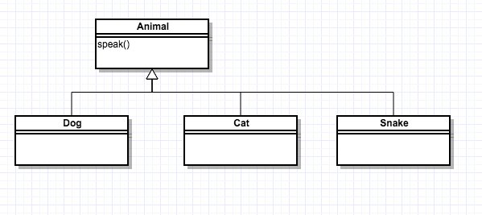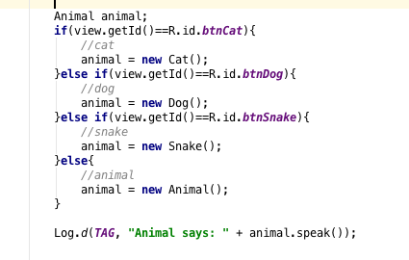
2. What about adding additional behavior?  
   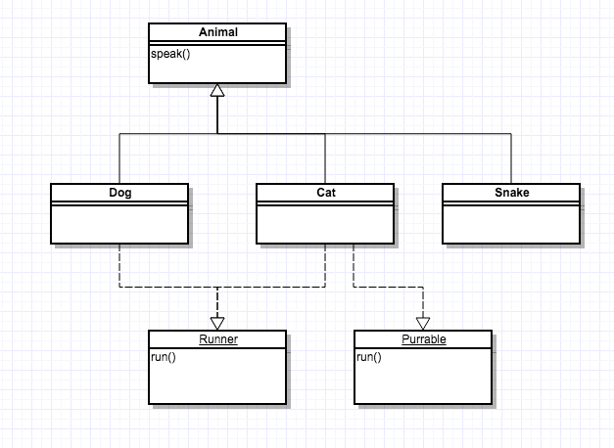

**Rock Paper Scissors**

1. Github
   1. Create a project on Git for Rock, Paper, Scissors
   2. Clone it down locally.
   3. Create an android project in that folder
   4. Push it
2. Create a wireframe/storyboard.
3. Initial Layout with images
4. Discuss RelativeLayout and LinearLayout
5. Create Click handler using **this**.
6. Create new Activity with an intent to the new page
   1. Player
   2. Some Text
   3. Computer
7. Add extra and display the passed in intent
8. Create a util to generate a random item for the opponent
9. Generate it and put it on the screen
10. Create some logic for the text
    1. Break the logic into smaller manageable pieces
11. Create Test cases for the logic
12. Map the logic on to the page
13. Create a click handler (anonymous inner class) for the entire page to start over
14. commit and push to github